Lutheran Social Ministries of NJ
Hygiene Bags for Senior Residents
- Toothpaste & toothbrush
- Shampoo & conditioner
- Soap (bar or body liquid)
- Comb & Brush
- Mouthwash
- Washcloths & towel
- Deodorant
- Large print word search or word find
- Emory boards, nail polish, polish remover

Hygiene Bags for Homeless men and women
- Toothpaste & toothbrush
- Shampoo & conditioner
- Soap (bar or body liquid)
- Comb & Brush
- Mouthwash
- Washcloths & towel
- Deodorant
- Disposable razors
- Female hygiene items
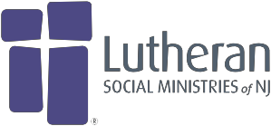
- New socks

Contact: Beth Gebhart, 609-699-4133
bgebhart@lsmnj.org for locations or more information.

Activities Bags for Senior Communities
- Yarn & knitting needles
- Bingo Prizes (lotion, note cards, costume jewelry, pen, men’s colon, magnets, etc.)
- Large print puzzle books
- Gift cards (grocery, drug store, Target or Walmart)

Cleaning Supplies for Shelter
- Bleach
- Dish detergent
- Laundry detergent
- Dryer sheets
- Disposable gloves (L & M)
- Hand sanitizer
- Tissues

